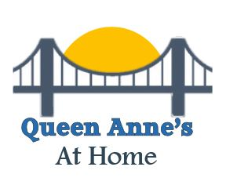

Update Newsletter

February, 2019

Board Buzz
Here’s a quick rundown of the Board’s work during the past couple of months:
- We welcomed Linda Schuerholz to the Board. Linda is already contributing by arranging SNAP Chapter presentations!
- We approved Bylaws, Articles of Organization and a Conflict of Interest policy.
- We are continuing work to make service requests an easy reality.
- We will create a monthly newsletter.
- We are discussing uses for possible grant funds.
- The Ambassadors Committee is continuing to seek opportunities for presentations.
- We will sponsor a coffee meet-up on the first Thursday morning of the month, a happy hour meet up on the third Thursday late afternoon of the month and a SNAP Chapter presentation in the middle of the month. Watch this newsletter and the web site for times and places.
We will always be receptive to any and all suggestions for making our At Home the best it can be.

Winter Preparedness Presentation

On Wednesday, January 23rd, Joe Cichocki from the Queen Anne’s County Department of Emergency Services gave a very timely presentation about Winter Weather Preparedness: what to do before, during and after a winter storm.
Given the past week of frigid temperatures, snow and ice, this was certainly a topic of interest. We now know the difference between a winter storm advisory, a watch and a warning as well as where that wind chill index comes from.

What to do before a storm includes checking the battery power for everything in your home that would rely on batteries during a power failure, as well as assuring that your vehicle battery can withstand freezing temperatures for a sustained period. Keep battery powered items like cell phones fully charged. Emergency kits in your home and vehicle(s) are important…and don’t forget about your pets’ needs.
Do you know the signs of hypothermia and frostbite? Watch yourself and others when outside shoveling snow (slowly and gently of course) or walking the dog. A person seeming confused or lethargic needs to seek warmth immediately. Frostbite is easily observed by another person, but the associated numbness might not so readily be recognized.
We all probably know about dressing in layers, but in spite reducing dexterity, mittens are always better than gloves. Inexpensive hand and foot warmers are good when used with a protective thin layer like silk gloves or socks to protect skin from the warmer.
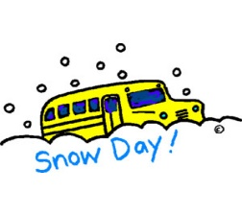
This Photo by Unknown Author is licensed under CC BY
This was a very informative presentation - intersperced with amusing commentary from Joe!

Interesting Tidbits

Are you interested in issues and information related to aging? Check out some informational links and see what's going on in the news.
https://www.washingtonpost.com/realestate/the-golden-girls-trend-could-be-a-golden-opportunity-for-retirees-facing-isolation/2019/01/23/6311a3f8-0ec8-11e9-831f-3aa2c2be4cbd_story.html
https://www.cnn.com/2019/01/18/tech/technology-elderly/index.html

Upcoming events
Caregiver Support Group
February 13th 1:30-3pm
QAC Area on Aging
104 Powell Street
Centreville
Happy Hour
Thursday February 21st at 4:30pm
Bridge's Restaurant
321 Wells Cove Road
Grasonville
SNAP Presentation
Psychology Around Fake News, Computer and Phone Scams
March 13th 2-4pm
Centreville Library
121 S. Commerce St.
Centreville

Questions? Or Want to RSVP for an event?
Call 410-635-4045

